**Name:** Harsh Chheda

**Roll Number:** 31031521005 / 22-15405

**Class:** Msc. Computer Science

**Subject**: Cloud Computing

**Year:** 2022-23

**INDEX**

|  |  |  |
| --- | --- | --- |
| **Sr no.** | **Title** | **Pg No.** |
| 1 | Implementation of Bare-metal and hosted virtualization | 3 |
| 2 | Implementation of containerization using Docker | 19 |

**Practical 1**

**Aim:** Implementation of Bare-metal and hosted virtualization

**Code:**

# Installation of VMWare WorkStation

## Step 1: [Click here](https://www.vmware.com/in/products/workstation-player/workstation-player-evaluation.html) and download the Work Station

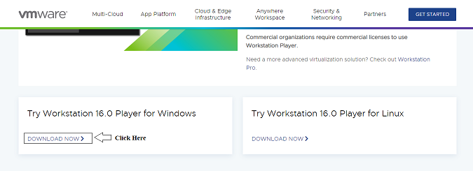

## Step 2: Once Downloaded double tap to start the installation

## Step 3: Click on Next

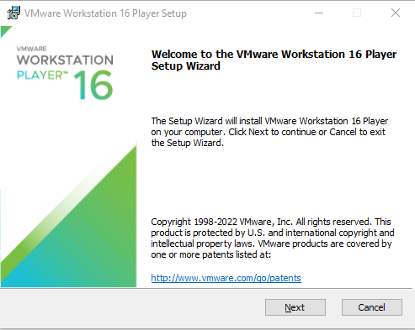

## Step 4: Check the terms and conditions and click on NEXT

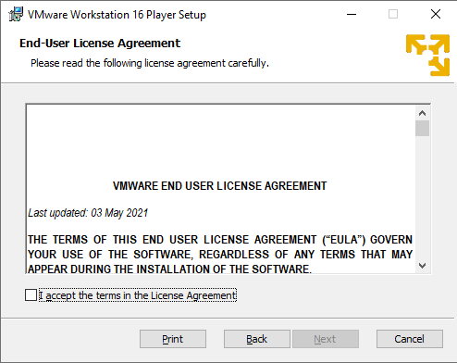

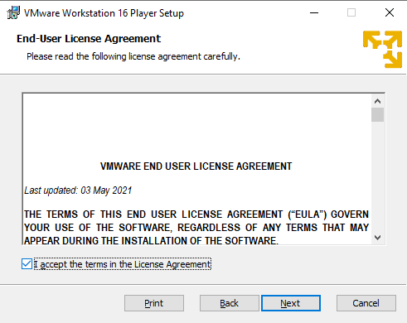

## Step 5: Keep the default setup and Click on NEXT

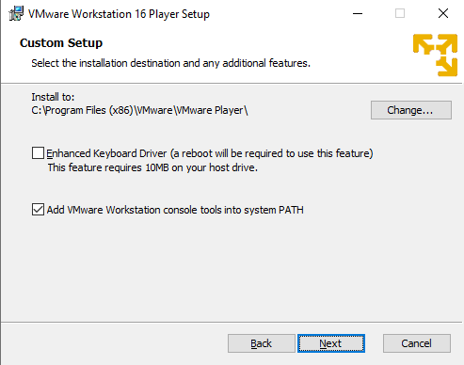

## Step 6: Click on NEXT

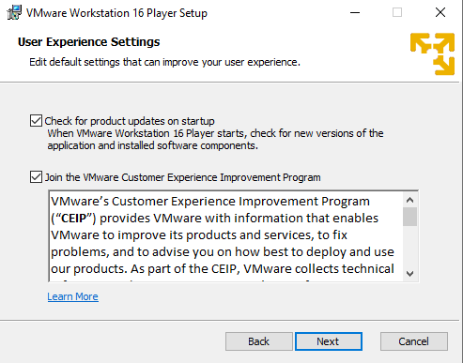

## Step 7: Click on NEXT

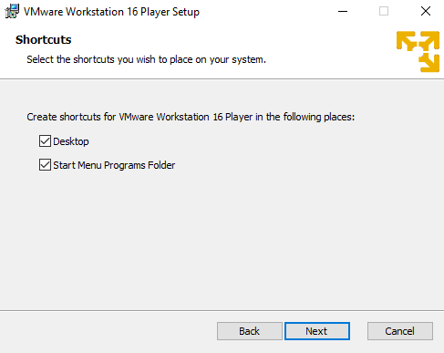

## Step 8: Click on INSTALL

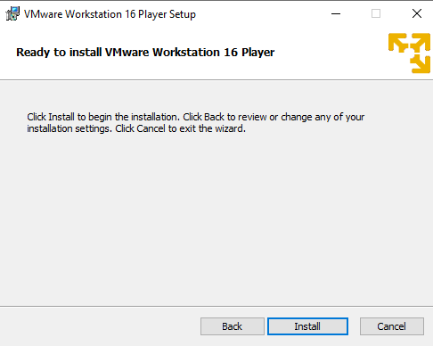

## Step 9: Once Finish the installation and you have the License Key then CLICK on the License Button and add the license key else click on FINISH

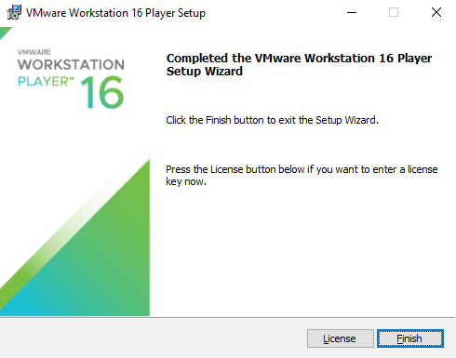

# Creation of the Virtual Machine in VMWare Workstation Pro

## Step 1: Open VM Ware WorkStation

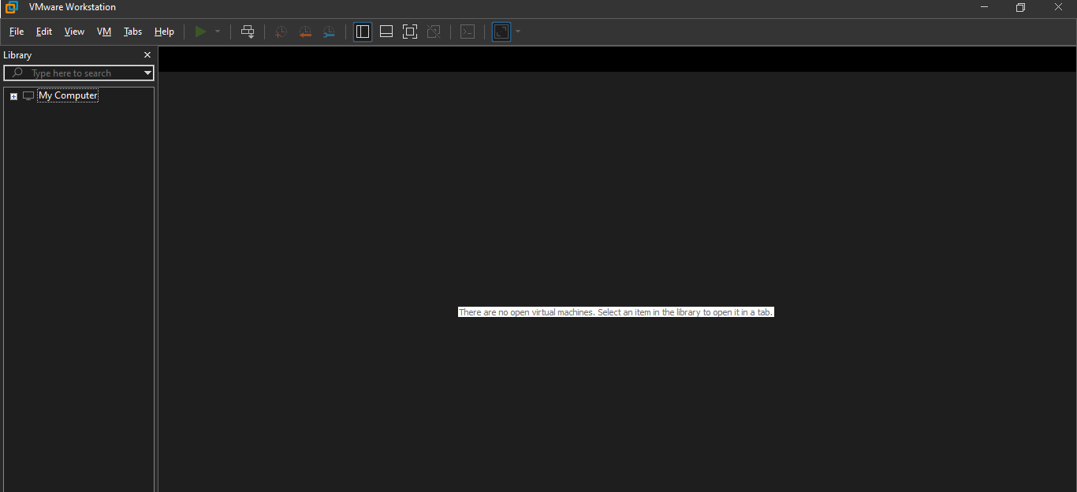

## Step 2: Click on File 🡪 Create New Virtual Machine

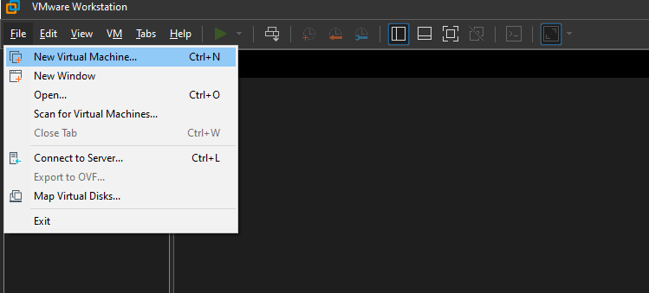

## Step 3: Select Typical and click on NEXT

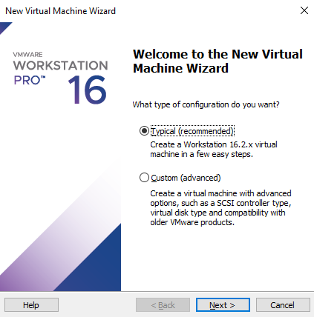

## Step 4: Click on Installer Disc_Image file and provide the ISO file path and click on NEXT

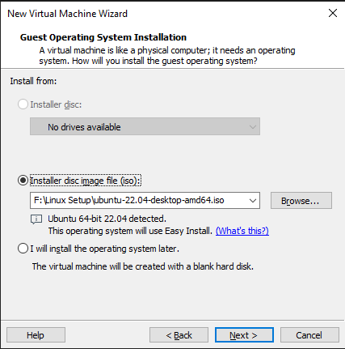

## Step 5: Provide the Full Name, Username and password and click on NEXT

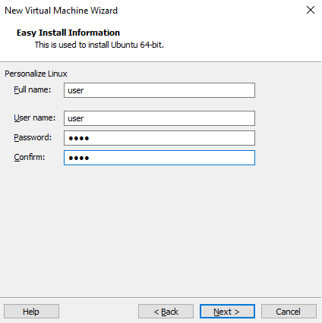

## Step 6: Provide the Virtual Machine Name and the path where to save the image

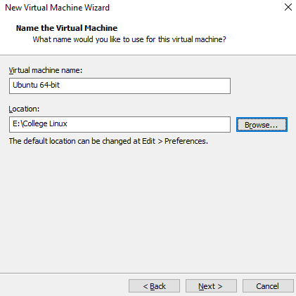

## Step 7: Provide the disk Size (Recommended 20GB) and click on NEXT

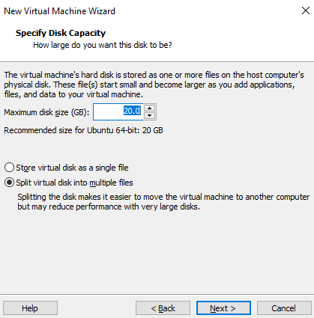

## Step 8: Click on FINISH

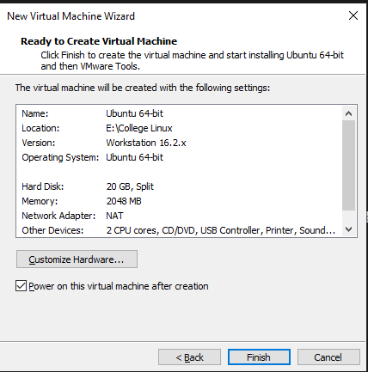

# Configuring and Installing Ubuntu

## Step 1: Run the Machine

## Step 2: Select the language and click on CONTINUE

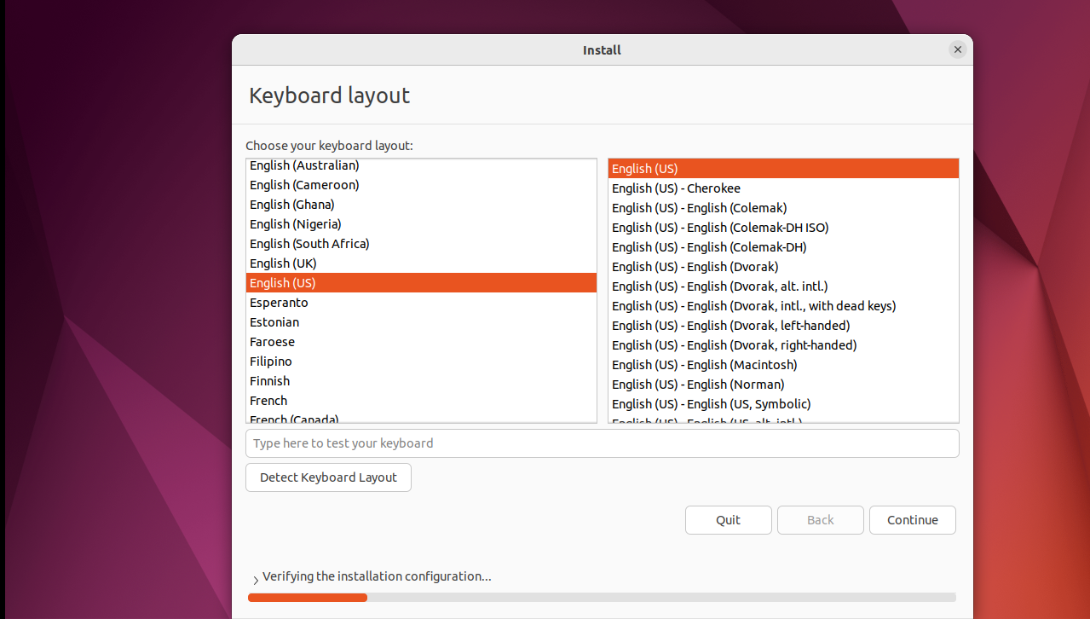

## Step 3: Click on CONTINUE

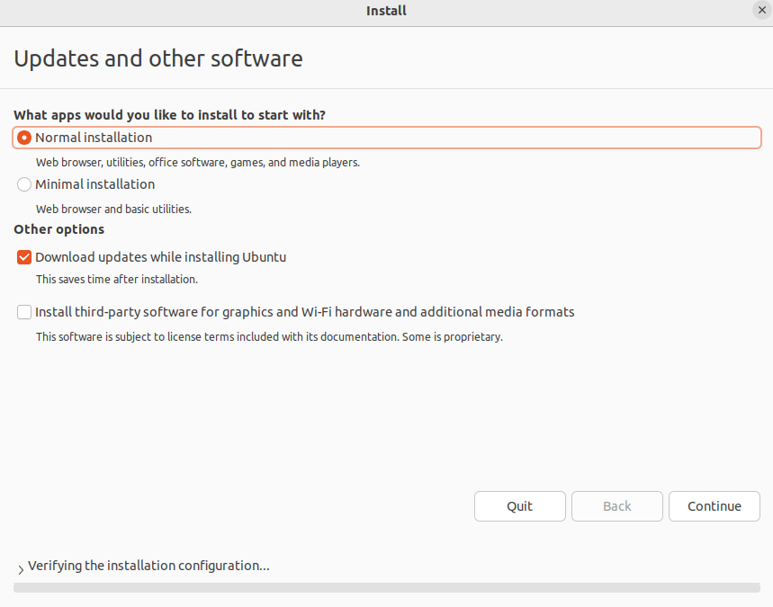

## Step 4: Click on Erase Disk and click on INSTALL

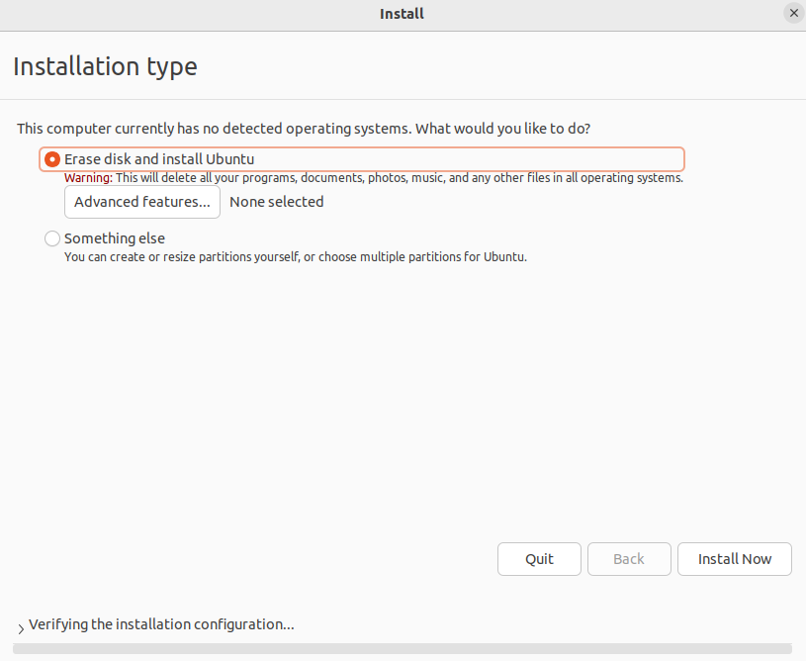

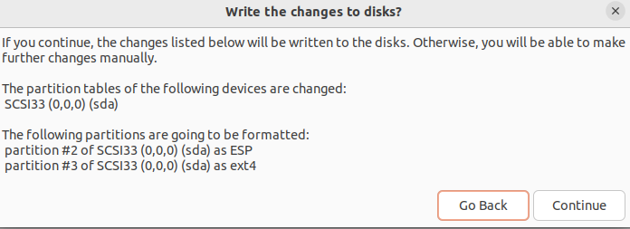

## Step 5: Select the Country and click on Continue

## 

## Step 6: Provide the Name, Username, and Password and click on Continue

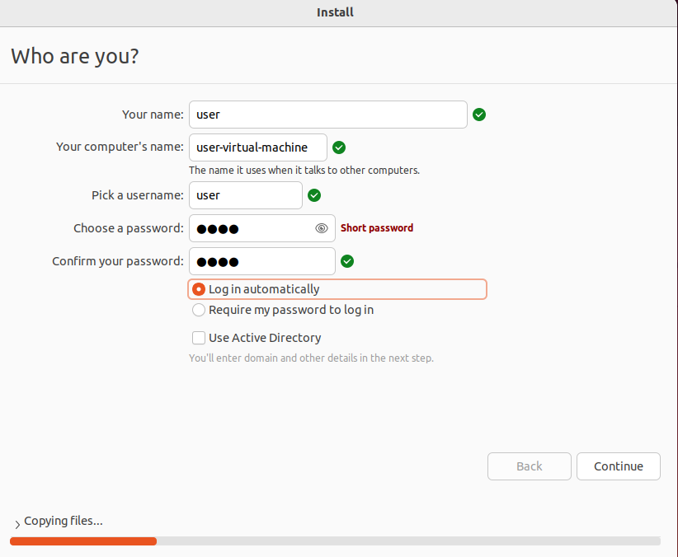

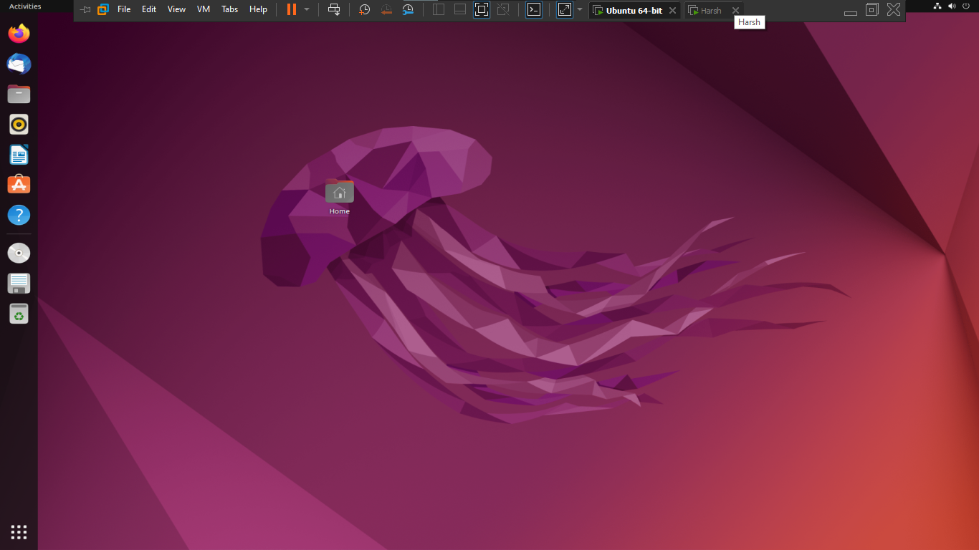

**Practical 2**

**Aim:** Implementation of containerization using Docker

**Code:**

# Installation of Docker

apt -y install docker.io

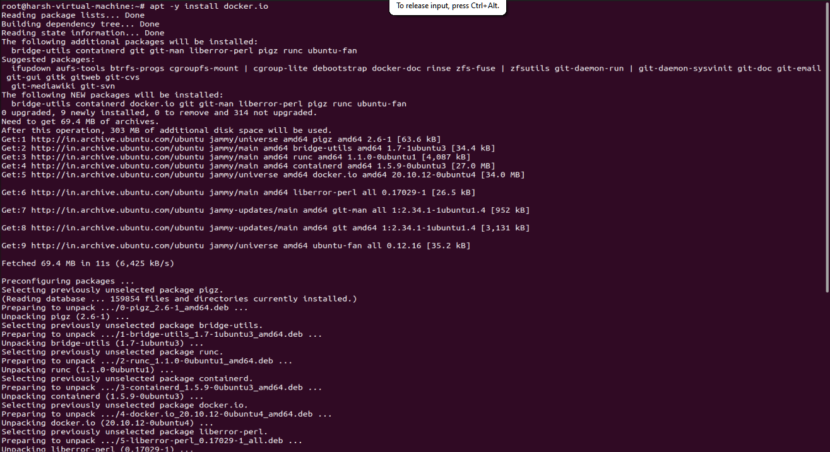

# Docker Version

docker version

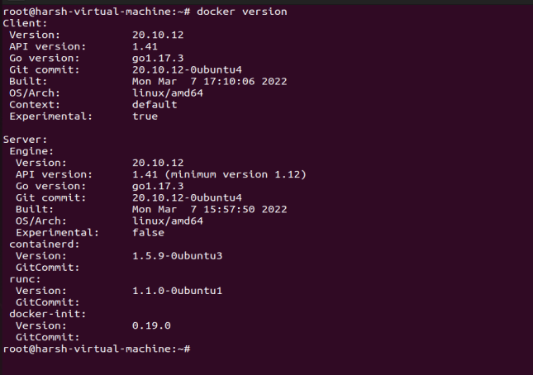

# Download an official image and create a container and output the words [Welcome to the Docker World] inside the container

## Downloading the official image

docker pull ubuntu

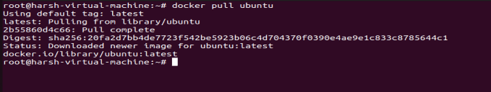

## Run echo inside the Container

docker run ubuntu /bin/echo "Welcome to the Docker World!"



# Connect to the interactive session of a Container with [i] and [t] option like follows. If exit from the Container session, the process of a Container finishes.

docker run -it ubuntu /bin/bash

uname -a

exit



# If exit from the Container session with keeping container's process, push [Ctrl+p] and [Ctrl+q] key.

 docker run -it ubuntu /bin/bash



## Show docker processes

docker ps

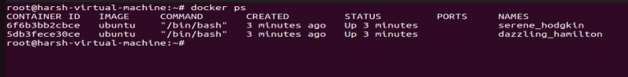

## Connect to container’s Session

docker attach 6f6b3bb2cbce

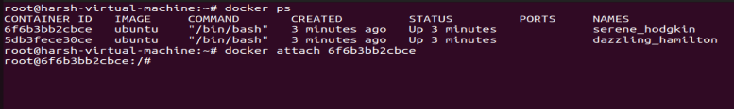

## Shutdown container’s process from Host’s console

docker kill 6f6b3bb2cbce

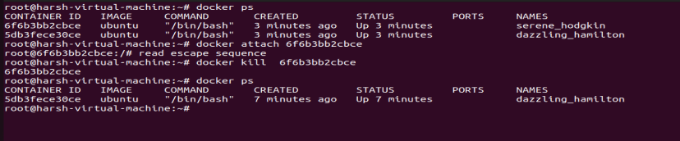

# Add Container images you created.

## For example, update official image with installing Nginx and add it as a new image for container. The container is generated every time for executing docker run command, so add the latest executed container like follows.

### Show images

docker images

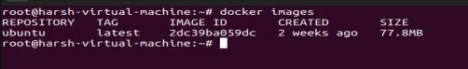

### Start a container and install nginx

docker run ubuntu /bin/bash -c "apt-get update; apt-get -y install nginx"

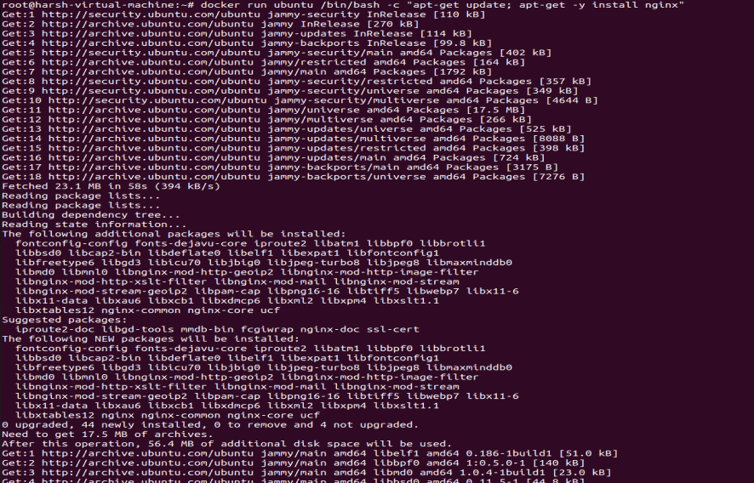

docker ps -a | head -2

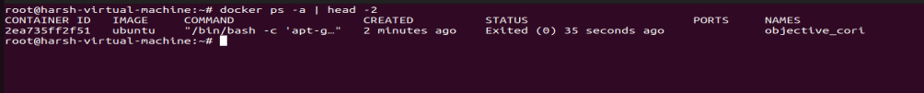

### Add the image

docker commit 2ea735ff2f51 srv.world/ubuntu-nginx

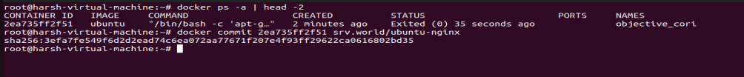

docker images

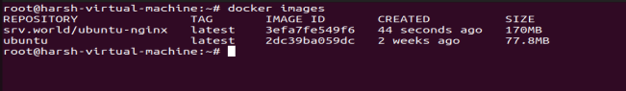

### Generate a container from the new image and execute [which] to make sure nginx exists

docker run srv.world/ubuntu-nginx /usr/bin/which nginx

